NoteFix – Intelligent Incident Note Editing
Document Owner: Sanetiq L2 Support Team
Version: 2.0
Classification: Internal – BlueBolt / Management Review

Index / Table of Contents
1.Problem Statement
  - Limitations
  - Examples
  - Original UI Screen and Note Section
2. Proposed Workflow
  - Purpose & Scope
  - Benefits
  - Use Cases of Enhanced Work notes
  - Enhanced & Secure Version of the Idea
  - Proposed Screenshot Explanation
  - Functional Workflow of Editable Notes
  - Controls Implemented in Proposed UI
  - Core Concept – Controlled Note Editing
  - End-to-End Workflow & Integration Model
- Classification & Reference Tables
- Common Pitfalls & Troubleshooting
- Original vs Proposed
- Technologies Used (ServiceNow Stack)

1. Problem Statement
In ServiceNow, support teams use the activity timeline to document updates through Work Notes (internal) and Additional Comments (customer-visible). However, once a note is posted, it cannot be edited or modified. This limitation creates challenges when engineers need to correct incorrect details, fix typographical errors, or add missing information. As a result, the timeline becomes fragmented and difficult to maintain as a single source of truth.
Core Problem
The core issue lies in the inability to update existing notes within the activity timeline. During incident handling, information evolves continuously, and initial entries may contain inaccuracies or incomplete details. Since editing is not supported, support engineers are forced to create multiple follow-up notes for corrections and updates, leading to duplication, confusion, and inefficiency in tracking the latest status of an incident.

1.1 Limitations
The current system has several limitations that impact usability and efficiency. Notes cannot be edited after submission, even for minor corrections. Incorrect or incomplete information remains permanently recorded unless clarified through additional entries. This results in duplicate and cluttered notes, making the timeline lengthy and difficult to navigate. It also increases the effort required for ticket reviews, audits, and shift handovers, as teams must analyze multiple entries to identify accurate information.
1.2 Examples of Existing System
Example 1: Correction Needed
- A support engineer posts:
Issue identified in Printer A at 10:30 AM
- Later realizes it was Printer B, not A
- Since editing is not available, the engineer adds another note:
Correction: Issue is with Printer B, not Printer A
Result: Multiple notes for the same update → confusion

Example 2: Missing Information
- Initial note:
Service is running fine
- Later information is added:
Additional info: Restart was done at 2:00 PM
Result: Information is split across notes, making it harder to track

Example 3: Typing/Error Issue
- Posted note:
Lable template issue identified
- Typo cannot be corrected → new note added:
Correction: Label template issue identified
Result: Unnecessary duplicate entries

Example 4: Continuous Updates
- Multiple follow-ups:
Investigation in progress
Waiting for logs
Logs received
Analysis completed
Instead of updating one note, several notes are added
Timeline becomes cluttered and lengthy

1.3 Original UI Screen Explanation (ServiceNow Activity Timeline)
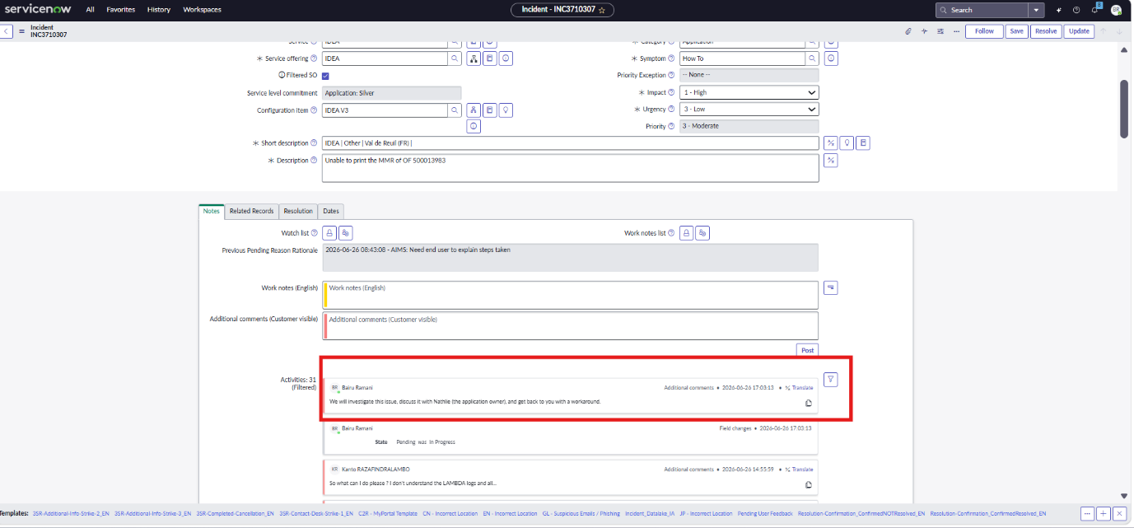
The image shows a ServiceNow Incident form (INC3710307).
1.3.1Top Section (Form Fields)
- Service Offering: IDEA
- Configuration Item: IDEA V3
- Short Description & Description:
  - Example: “Unable to print the MMR…”
- Impact, Urgency, Priority fields
This section is used to define the incident details.
1.3.2. Notes Section (Main Working Area)
Below the form, there are multiple tabs:
- Notes (selected)
- Related Records
- Resolution
- Dates
Inside Notes Tab:
You can see two input fields:
Work Notes (Internal)
- Used by support team only
- Not visible to customer
Additional Comments (Customer Visible)
- Visible to end users
Users type updates here and click Post

1.3.3 Activity Timeline (Highlighted in Red Box)
This is the most important part.
What it shows:
Each entry in the timeline contains:
- User name (example: Bairu Ramani)
- Note type: Additional comments
- Timestamp: 2026-06-26 17:03:13
- Message:
“We will investigate this issue… and get back to you…”
- Translate option
- Small action icons (like share/log)

Notice what is missing:
- ❌ No Edit button
- ❌ No option to modify the note
- ❌ No update functionality

1.3.4 Work Flow Of Existing UI
Step 1: User adds note
- Enters text in “Additional Comments”
- Clicks Post
Step 2: Note appears in timeline
- Saved permanently
- Linked with timestamp
Step 3: If mistake happens
Examples:
- Wrong info → cannot fix
- Missing detail → cannot update
- Typo → cannot correct
User must create a new note

Example of Current Problem
Instead of one correct note:
What happens now:
Entry 1: Issue in Printer A
Entry 2: Correction: Issue is Printer B
Entry 3: Restart done
Result:
- Timeline becomes long and messy
- Hard to track latest truth

Activity Counter & Filtering
- "Activities: 31 (Filtered)" Shows number of entries
- Filter icon present Used to filter activity types

Other Observations
No Edit History
- Only original entry visible
- No "Edited by..." indicator
Static Data Model
- Uses journal fields
- These are:
  - Append-only
  - Non-editable by design

Problem Demonstrated by This Screen
Issue | Explanation
No edit capability | Users cannot correct mistakes
Duplicate entries | Every correction requires new note
Cluttered timeline | Multiple fragmented updates
Hard to review | Must read all notes to understand status
No clarity | Latest information not clearly visible

Why ServiceNow Designed It This Way
ServiceNow intentionally:
- Prevents editing of journal fields
- To ensure:
  - Strong audit trail
  - No tampering of records
BUT: It sacrifices usability and flexibility, which your idea addressess

2. Proposed Workflow
The proposed workflow introduces a controlled editing mechanism for notes. When a support engineer identifies an error or needs to update information, an “Edit” option becomes available under specific conditions. These conditions include the user being the original creator of the note, having the appropriate support role, and the ticket being in an active state such as New, In Progress, or Pending. The engineer can then modify the content directly without adding a new note. The system validates permissions and records all changes in an audit log, capturing the original and updated content along with timestamps. Once the ticket is moved to Resolved or Closed, editing is permanently disabled.

2.1 Purpose & Scope
The purpose of this solution is to improve the accuracy, clarity, and usability of the ServiceNow activity timeline by enabling controlled note editing. It aims to reduce duplication, ensure up-to-date information, and enhance operational efficiency. The scope of this solution includes the Incident Management module and applies specifically to Work Notes and Additional Comments. Editing functionality is restricted to support team users under role-based, creator-based, and state-based conditions, while end users are intentionally excluded to maintain system integrity and compliance.

2.2 Benefits
Implementing this solution provides significant benefits to both support teams and the organization. It results in a cleaner and more organized timeline by reducing redundant entries and consolidating updates into a single note. It ensures that the most accurate and current information is always visible, which improves decision-making and incident handling efficiency. Additionally, it simplifies ticket reviews, audits, and shift handovers by eliminating the need to analyze multiple notes. With built-in audit tracking and strict access controls, the solution maintains accountability, data integrity, and compliance with ServiceNow standards while enhancing overall user experience.

2.3 Use Cases of Enhanced Work notes
1. Correcting Incorrect Information
- A support engineer enters wrong details (e.g., wrong printer name, timestamp)
- Instead of adding a new correction note, the engineer can edit the existing note
- Ensures only accurate information is visible

2. Fixing Typographical Errors
- Notes may contain spelling mistakes or incomplete sentences
- With edit option, users can quickly correct errors without adding duplicate notes Keeps timeline clean and professional

3. Updating Incomplete Notes
- Initial note may be:
Investigation in progress
- Later, more details are available
- Instead of multiple follow-ups, the note can be edited and updated
- Maintains single consolidated update

4. Avoiding Duplicate Entries
- Currently:
  - One note for initial update
  - Another note for correction
  - Another for additional info
- With edit option:
  - All updates can be maintained in one single note
  - Reduces clutter in activity timeline

5. Maintaining Latest Accurate Status
- While troubleshooting, information changes frequently
- Editing allows keeping latest status in one place
- Helps team and stakeholders quickly understand current progress

6. Efficient Ticket Review
- During handovers or audits, support engineers review notes
- Editing ensures notes are clean, precise, and up-to-date
- Saves time and improves clarity

2.4 Enhanced & Secure Version of Your Idea
Improved Proposed Solution
- Introduce a single “Edit” option for existing notes
Security Controls Added
- Creator-Based Editing
  - Only the user who created the note can edit it
  - Prevents unauthorized modifications
- State-Based Restriction
  - Notes can be edited only when ticket is in:
    - Pending
    - In Progress
  - Editing should be disabled when status = Closed/Resolved
- Role-Based Visibility
  - Edit option visible only for support team users
- Audit Tracking
  - Maintain:
    - Original content
    - Edited content
    - Edited by
    - Edited timestamp

Why This Makes Your Idea Stronger
1. Protects Original Data
- Ensures:
  - Only the person who wrote the note can change it
  - Prevents misuse or tampering

2. Maintains Process Integrity
- Restricting editing to:
  - Pending / In Progress states Ensures:
- Once ticket is closed → no changes allowed
- Keeps final audit reliable

3. Improves Accountability
- Every edit is:
  - Controlled
  - Traceable
Builds trust in system data

4. Aligns with ServiceNow Standards
ServiceNow prefers:
- Controlled updates
- Strong audit trail
Your idea now: Does NOT break compliance
Works within best practices

Updated Drawback (Now Reduced)
Even with controls:
- Minor risk:
  - User may edit important details before closure
But reduced because:
- Only creator can edit
- Limited to active states
- Audit history exists

NO edit option for users (customers/end users)
Editing control only under strict conditions (or possibly no edit at all for end users)

Comparison with Your Proposed UI
Feature | Original UI | Your Proposed UI
Edit option | ❌ Not available | ✅ Available
Error correction | ❌ New note needed | ✅ Inline edit
Timeline | ❌ Fragmented | ✅ Clean
Audit | ✅ Implicit only | ✅ Explicit (Edited info)
Usability | ❌ Low | ✅ High

2.5 Proposed Screenshot Explanation (Editable Notes UI)
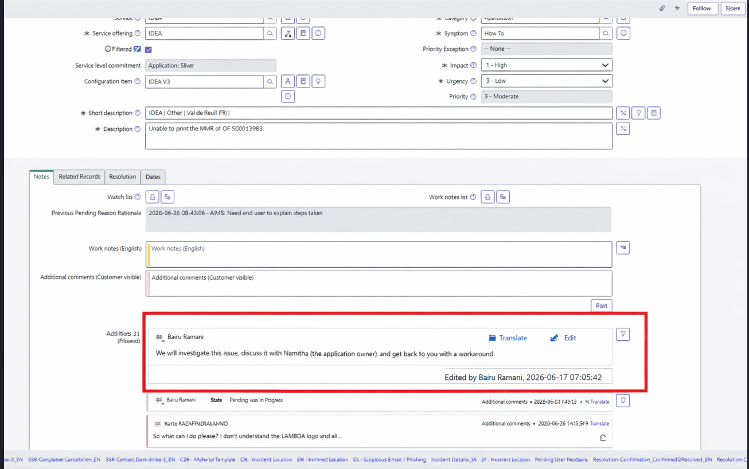

Overall Context
The screenshot shows a ServiceNow Incident form – Notes section, where:
- Users can add:
  - Work Notes (internal)
  - Additional Comments (customer-visible)
- Below these fields, the Activity Timeline displays previously added notes.

Highlighted Section (Red Box)
The highlighted section represents your enhanced editable note design.
Key Elements Visible:
1. Note Author & Content
A note is displayed with:
  - Author name (example: Bairu Ramani)
  - Message:
"We will investigate this issue, discuss it with Namitha... and get back to you with a workaround."
This is a standard activity entry.

2. New Feature: “Edit” Option
On the right side of the note, you can see:
- ✏️ Edit
- 🌐 Translate (existing feature)
The Edit button is your proposed feature
Purpose:
- Allows the user to modify the existing note directly
- Eliminates need for correction follow-up notes

3. Edited Indicator (New Enhancement)
Below the note:
"Edited by Bairu Ramani, 2026-06-17 07:05:42"
Significance:
- Shows:
  - Who edited the note
  - When it was edited
This is critical for:
- Audit tracking
- Transparency
- Compliance

4. Single Consolidated Note
Instead of:
Note 1 → Initial message
Note 2 → Correction
Note 3 → Additional update
Only one note exists, updated over time
Result:
- Clean UI
- Less clutter
- Easier readability

2.6 Functional Workflow of Editable Notes
Step 1: User adds note
- Initial comment is created and shown in timeline
Step 2: User finds an issue
- Wrong info / missing detail / typo
Step 3: User clicks Edit
- Edit option appears (based on conditions)
Step 4: Edit UI opens
- Note becomes editable (popup or inline)
Step 5: Save
- Updated content replaces old content
Step 6: System adds audit info
- "Edited by..." line appears

2.7 Controls Implemented in Proposed UI
Even though not directly visible, this UI supports:
Control Type | How It Works
Creator-based | Only the person who wrote the note sees "Edit"
Role-based | Only support users have this option
State-based | Edit hidden if ticket is Closed/Resolved
Audit tracking | "Edited by + timestamp" shown

What Makes This Screenshot Powerful
1. Minimal UI Change
- No major redesign
- Just adds Edit option + audit label
2. High Usability
- Easy to understand
- Works like common chat/email edit behavior
3. Maintains ServiceNow Standards
- Activity still visible
- No loss of traceability

2.8 Core Concept — Controlled Note Editing
The core concept is to enable secure and controlled editing while preserving data integrity.
Key Principles:
- Notes should act as a single source of truth
- Editing must:
  - Be restricted and traceable
  - Not compromise audit history
Concept Summary:
- Allow users to correct or update existing notes
- Avoid unnecessary multiple entries
- Maintain clean and accurate documentation

2.9 End-to-End Workflow & Integration Model
Phase A: Incident Creation
- Incident is created
- Initial note is added by support engineer

Phase B: Investigation Begins
- Engineer adds work notes with findings
- Information may be partial or subject to change

Phase C: Error or Update Identified
- Engineer identifies:
  - Incorrect entry
  - Missing detail
  - Updated findings

Phase D: Edit Option Availability
- “Edit” button becomes visible when:
  - User = note creator
  - Role = support team
  - State = In Progress / Pending

Phase E: Note Editing
- User modifies:
  - Incorrect data
  - Adds missing details
- No new note creation required

Phase F: Save & Validation
- System validates:
  - Role
  - Ownership
  - State
- Updates note in system

Phase G: Audit Logging
- System records:
  - Original content
  - Updated content
  - Modified by
  - Modified timestamp

Phase H: Final Lock
- When status becomes:
  - Resolved / Closed
- Edit option is disabled permanently

Integration Model
ServiceNow Integration Approach
Since journal fields cannot be edited directly:
Implementation:
- Create:
  - Custom editable field (e.g., u_editable_notes)
- Add:
  - UI Action (Edit button)
- Apply:
  - Role-based and state-based logic

System Flow
User → Click Edit → Modify Note → Validate → Save → Audit Log Updated

Components Involved
- UI Action (Edit button)
- Client Script / UI Policy
- Business Rule (validation)
- Audit Table

3 Classification & Reference Tables
User Role Access
Role | Permission
Support Team | Edit allowed (with restrictions)
End User | No edit access
Admin | Full access

State-Based Control
State | Edit Allowed
New | ✅ Yes
In Progress | ✅ Yes
Pending | ✅ Yes
Resolved | ❌ No
Closed | ❌ No

Edit Conditions
Condition | Requirement
Note creator | Mandatory
Support role | Mandatory
Active state | Mandatory

Audit Fields
- Created By
- Created On
- Modified By
- Modified On
- Previous Value
- Updated Value

4 Common Pitfalls & Troubleshooting
Pitfall 1: Unauthorized Editing
- Issue: Other users modifying notes
Solution:
- Restrict editing to:
  - Note creator only
  - Support roles

Pitfall 2: Loss of Original Data
- Issue: Overwriting critical information
Solution:
- Enable full audit tracking
- Maintain history of changes

Pitfall 3: Editing After Closure
- Issue: Compromised audit compliance
Solution:
- Disable edit when:
  - State = Closed / Resolved

Pitfall 4: Misuse of Feature
- Issue: Frequent unnecessary edits
Solution:
- Limit editing permissions
- Track usage via logs

Pitfall 5: Platform Constraint
- Issue: ServiceNow does not allow direct editing of journal fields
Solution:
- Use:
  - Custom editable fields
  - UI Action-based editing approach

5. Current Vs Enhanced
Aspect | Current State | Expected State
Note Editing Capability | Once a note is added in Work Notes or Additional Comments, it becomes permanently locked. No option exists to modify or update the content, even for minor corrections. | A controlled “Edit” option is introduced, allowing users to modify their notes under strict conditions such as role, ownership, and ticket state, ensuring flexibility without compromising control.
Error Correction Process | When incorrect information is entered (e.g., wrong device name or time), users must create a separate correction note, leading to multiple entries for a single update. | Users can directly correct incorrect information within the same note, eliminating the need for additional correction entries and ensuring clarity in communication.
Information Flow & Continuity | Information is fragmented across different notes, making it difficult to follow the sequence of updates and understand the complete story of the incident. | Information is continuously updated within a single note, ensuring a smooth and logical flow that is easy to understand and track.
Timeline Structure & Readability | The activity timeline becomes cluttered with multiple small updates, corrections, and follow-ups, reducing readability and increasing cognitive load. | The timeline remains clean and structured, with fewer but more meaningful entries, improving readability and simplifying navigation.
Handling Typographical Errors | Even minor spelling or grammatical mistakes cannot be corrected, resulting in unprofessional-looking notes or unnecessary duplicate corrections. | Users can instantly fix typographical and formatting errors, ensuring professional and accurate documentation.
Duplicate Entries | Multiple entries are created for initial updates, corrections, and additional information, leading to redundancy and confusion. | Duplicate entries are significantly reduced as updates are consolidated within existing notes through editing.
Tracking Latest Update | Users must manually identify the latest correct update by reading through multiple notes, which is time-consuming and error-prone. | The latest and most accurate information is always available in the updated note, reducing ambiguity and review effort.
User Effort & Productivity | Engineers spend extra time writing multiple updates and reviewing long timelines, reducing overall productivity. | Engineers can quickly update existing notes, saving time and focusing more on issue resolution rather than documentation overhead.
Shift Handover Efficiency | During handovers, incoming team members must analyze multiple notes to understand the current status, increasing the risk of misinterpretation. | Consolidated and updated notes provide clear and concise information, enabling faster and more effective handovers.
Audit & Traceability | Only the original notes exist, but corrections are scattered in separate entries, making it difficult to track what changed and when. | A structured audit trail captures original and updated content, along with user and timestamp details, ensuring full traceability and transparency.
Data Accuracy & Reliability | Incorrect or outdated information may remain visible and cause confusion, reducing trust in the system data. | Data remains accurate and reliable as users can continuously refine and correct information within controlled boundaries.
User Ownership & Accountability | No direct ownership over corrections; any user may add clarification notes, leading to lack of accountability for original entries. | Only the original note creator can edit their content, ensuring responsibility and ownership of information.
Access Control Mechanism | No editing feature exists, so no control logic is applied. | Editing is restricted using role-based access (support team only), ensuring that only authorized users can perform updates.
State-Based Governance | Notes remain static regardless of the ticket state; no logic ensures control after closure. | Editing is allowed only in active states (New, In Progress, Pending) and is automatically disabled when the ticket is resolved or closed.
Post-Closure Integrity | Incorrect or incomplete notes remain unchanged even after closure, potentially impacting audits and reporting. | Editing is disabled post-closure to preserve final record integrity, ensuring compliance with audit and regulatory requirements.
Operational Efficiency | Excessive notes and manual effort reduce operational efficiency and increase handling time for incidents. | Streamlined updates and reduced duplication significantly improve operational efficiency and ticket handling speed.
User Experience (UX) | Users experience frustration due to lack of flexibility and repetitive effort required to maintain accurate notes. | Enhanced UX with intuitive editing capability, reducing effort and improving satisfaction for support engineers.
Compliance & Best Practices | While static notes help compliance, fragmented corrections can reduce clarity and audit usability. | Controlled editing with full audit tracking aligns with ServiceNow best practices, ensuring both flexibility and compliance.
System Maintainability | Over time, large volumes of redundant notes increase data clutter and make maintenance harder. | Optimized note management reduces data clutter and improves long-term maintainability of the system.
Decision-Making Support | Decision-making may be impacted due to scattered or outdated information across multiple notes. | Accurate and updated notes provide reliable data for faster and better decision-making.
6. Technologies Used (ServiceNow Stack)
Core Platform
- ServiceNow (Incident Module)
- Agent Workspace / UI16
Frontend (UI Layer)
- UI Action (Edit Button)
- Client Script (onClick logic)
- UI Policies (visibility control)
Backend (Server Logic)
- Business Rules
- Script Includes (optional for reusable logic)
Data Layer
- Custom Table (u_editable_notes)
- Audit Table (u_editable_notes_audit)

6.1 Step-by-Step Implementation
Step 1: Create Custom Table
Create a new table:
Table Name: u_editable_notes
Fields:
Plain Text
incident (Reference → Incident)
note_text (String / HTML)
created_by (User)
created_on (DateTime)
updated_by (User)
updated_on (DateTime)
Purpose:
- Since journal fields can't be edited → this acts as editable storage

Step 2: Create Audit Table
Table: u_editable_notes_audit
Fields:
Plain Text
note_id (Reference)
original_content (String)
updated_content (String)
edited_by (User)
edited_on (DateTime)
Purpose:
- Maintain full edit history

Step 3: Add UI Action (Edit Button)
Create a UI Action on Incident form:
Conditions:
Plain Text
current.state != Closed
AND current.state != Resolved
AND gs.hasRole('itil')

Script:
JavaScript

function editNote(noteId) {
var url = "/u_edit_note.do?sys_id=" + noteId;
g_navigation.openPopup(url);
}
``
Show more lines

Button Label: Edit Make it visible only for note owner

Step 4: Create Client Script
Type: onClick / UI Script
Logic:
JavaScript
if (g_user.userID != note_creator) {
alert("You can edit only your own note.");
return false;
}

if (g_form.getValue('state') == 'Closed') {
alert("Editing not allowed after closure.");
return false;
}
Validates:
- User ownership
- Ticket state

Step 5: Create Edit UI Page / Modal
Create a UI Page (u_edit_note)
Components:
- Text area (pre-filled with existing note)
- Save button
Step 6: Business Rule (Server-side Validation)
Type: Before Update
Logic:
JavaScript

if (current.updated_by != current.created_by) {
gs.addErrorMessage("Unauthorized edit");
current.setAbortAction(true);
}

if (current.incident.state == 'Closed') {
gs.addErrorMessage("Editing not allowed");
current.setAbortAction(true);
}
Ensures:
- Security at server level (not just UI)

Step 7: Audit Logging
Create a Business Rule (After Update)
JavaScript

var audit = new GlideRecord('u_editable_notes_audit');
audit.initialize();
audit.note_id = current.sys_id;
audit.original_content = previous.note_text;
audit.updated_content = current.note_text;
audit.edited_by = gs.getUserID();
audit.edited_on = gs.nowDateTime();
audit.insert();

Step 8: Display Notes in UI
Modify Incident form:
- Add related list of u_editable_notes
- Show:
  - Latest updated note
  - Option to edit

Step 9: Enforce State-Based Rules
Use:
- UI Policy (hide edit button if closed)
- Business Rule (hard validation)

Security Implementation

Control | Implementation
Creator-based | Compare created_by == current user
Role-based | gs.hasRole('itil')
State-based | Validate state != closed/resolved
Audit tracking | Separate audit table

